**TRADING AND SHIPMENT APPLICATION DOCUMENT**

1. **Analysis of the functional view:**

* 1. **Business Objectives:**

Objective: To develop an application for Trading and Shipment of Coal, Barite, Bauxite and Alumina

Key Stakeholders: Traders, investors, Shippers, compliance officers, IT teams.

* 1. **Requirement Gathering:**

An application for the overall process of trading and shipment with the respective approvals (User privileged access) has been freezed as an requirement (MVP) for phase 1

Market data visualization (real-time shipment prices, news feeds in the trading field).

Portfolio management (Overall dashboard, performance analytics).

Risk management (compliance checks, user privileged access).

* 1. **High Level Functionalities:**
* Order ID
* Terms Sheet
* Document Collection
* LC
* Vessel
  1. **Functional Requirements:**
* Inputs, outputs, and processing logic for order placement and execution.
* Real-time data retrieval mechanisms for market prices and news feeds.
* Integration interfaces with warehouse management systems (WMS) for inventory control.
  1. **Document Functional Specifications:**
* Use cases for each functional requirement.
* Acceptance criteria and validation rules.
* Integration points with external systems (e.g., market data providers, trade execution platforms).
* Define user roles and permissions for accessing shipment data.
* Specify notification triggers and communication protocols for customer updates.
  1. **Collaborate with Development Teams:**
* Participate in design reviews and provide clarifications on functional specifications.
* Verify that implemented features align with business needs and user expectations.
  1. **Validate Requirements with Stakeholders:**
* Demonstrate prototypes to gather feedback in UAT.
* Incorporate feedback into iterative improvements and refinements.
* Gather feedback from logistics teams and drivers on system usability and performance.

1. **Please find the various functionality flows below:**
   1. **Shipment Workflow:**

* 1. **Trading Workflow:**

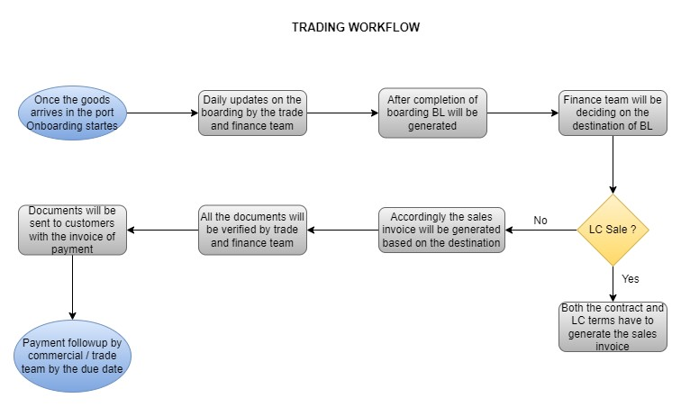

* 1. **Shipment Profitability Clasification :**

1. **High Level Project Plan:**

Please find the below link which contains High Level Project Plan

<https://docs.google.com/spreadsheets/d/1WjeQZb_M_WDbpIpvazXp7L05Et5ni-uR/edit?usp=sharing&ouid=102423586283611143216&rtpof=true&sd=true>

1. **KPIs to achieve successful project:**
   1. Order completion rate: The proportion of client orders that are successfully completed in a time frame.
   2. Shipping lead time: The typical amount of time between placing an order and having it shipped out.
   3. Customer satisfaction score (CSAT): A measure of how satisfied consumers are with the shipping procedure generally, including the quality of the packaging, delivery time, and overall experience.
   4. The freight cost as a percentage of sales is a metric used to assess how cost-effective shipping is in relation to overall sales income.
   5. Inventory turnover ratio: The rate at which stock is sold and refilled, signifying effective resource management.
   6. Customs clearance time: Average time taken for shipments to clear customs, minimizing delays and ensuring timely delivery.